1A – Financial Mathematics – Lesson 01
Credit Cards – Interpreting Statements.

Name: _________________

- Is it a good idea to view Credit Card statements online? Why?

- Use the statement below to answer then following questions.
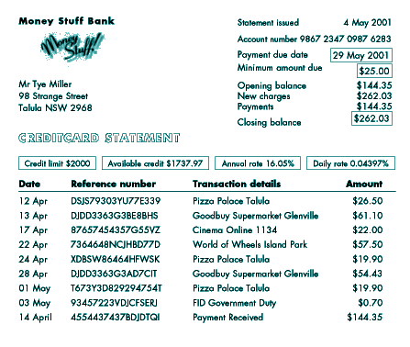
[source: www.moneystuff.net.au/Default.aspx?tabid=226]

  - What is the date the statement was issued? _______

  - By what date is the payment due? _______

  - Did Tye owe any money on his credit card at the beginning of this statement?

  - What is the total purchase amount in the period shown?

  - What is the total Tye had to pay by the due date to avoid any credit charges?
- Create a Savings Ledger for the following data.

Weekly Savings Ledger
Income |  | Expenditure
Total |  | Total

Average weekly income $900. Average weekly spending Rent $350, Shopping $250, Dinner $120 and Petrol $70.

    - What are the savings?

    - Complete the Ledger above.

- Complete the Spending Journal below.

Date | Details | Income | Expenditure

1/6 – Pay - $1200  7/6 – Rent - $450  21/6 – Rent - $450 | 2/6 – Shopping - $240  15/6 – Pay - $1200  26/6 – Dinner - $90 | 5/6 – Movies - $30  16/6 – Shopping - $200  31/6 – Interest - $80

- Why do we need to keep these records if we have a have a credit card?

